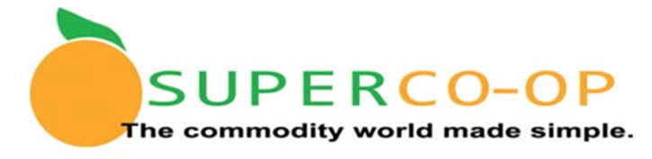
Super Co-Op Fee Structure
School Year 2022-2023

**Please Remit all fees promptly when billed

Type | Billing Agency | Amount | Frequency | Notes
Membership Fees | San Mateo-Foster  City School District  (Co-Op Lead Agency) | 0.4% of Entitlement | First membership year
 |  | 0.3% of Entitlement | Subsequent membership years
 |  |  | Bill sent to Member Districts July 1 Annually
State Administrative Fees | Administrator  (Gold Star Foods) | Direct Delivery (Brown Box)  $.90/case | On receipt at Distributor | Administrator forwards state fees to Lead Agency for remittance to state.
 |  | Processed Commodity  $.90/case | Monthly based on % of total Entitlement.
 |  | DOD Produce  $.15/case | Annually @ end of year
Delivery  Direct Delivery  USDA Foods (Brown Box) | Distributor  (Gold Star Foods) | $2.36/case | On receipt at Member District | Notice of arrival on distributor (Gold Star Foods) website. Order on distributor website. Payment terms: NET 30.
25 case minimum delivery to
1 site/1 time per week
 |  | No minimum case requirement if combined with other commercial delivery
Storage  Direct Delivery  USDA Foods (Brown Box) | Distributor  (Gold Star Foods) | $0.95/case/month after first 30 days following delivery to Gold Star Foods | As ordered by Member District | Notice of arrival on distributor (Gold Star Foods) website. Order on distributor website. Payment terms: NET 30.
Delivery  Processed USDA Foods | Distributor as selected by Member District | Varies by Distributor | As ordered by Member District
 | Processor Direct | Varies by Processor | As ordered by Member District
Delivery  DOD Produce | Distributor | Varies by Distributor | As ordered by Member District

Revised: 06/03/2022

